

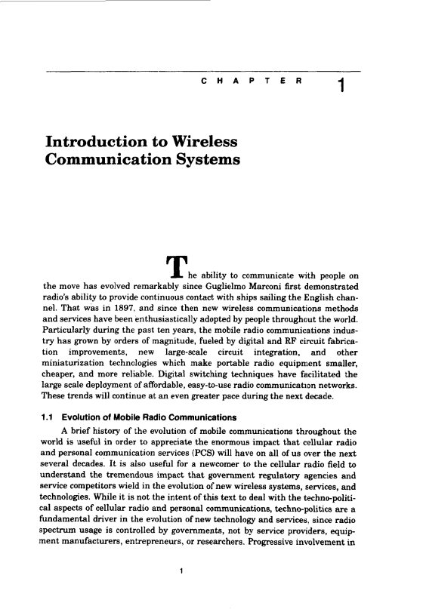www.vsofts.net oldroad

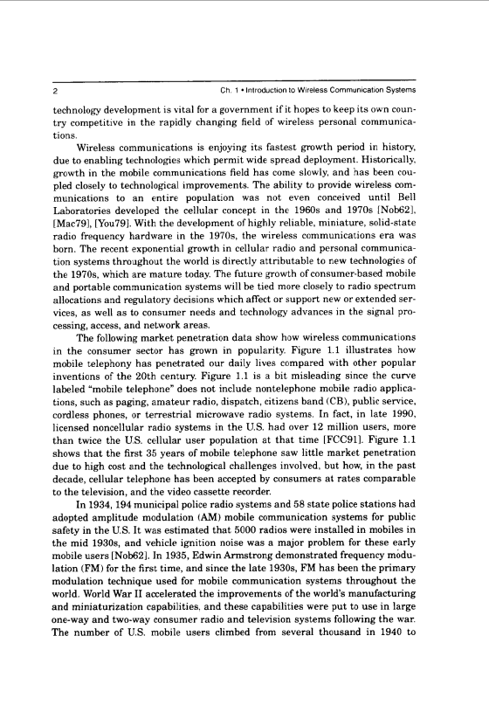www.vsofts.net oldroad

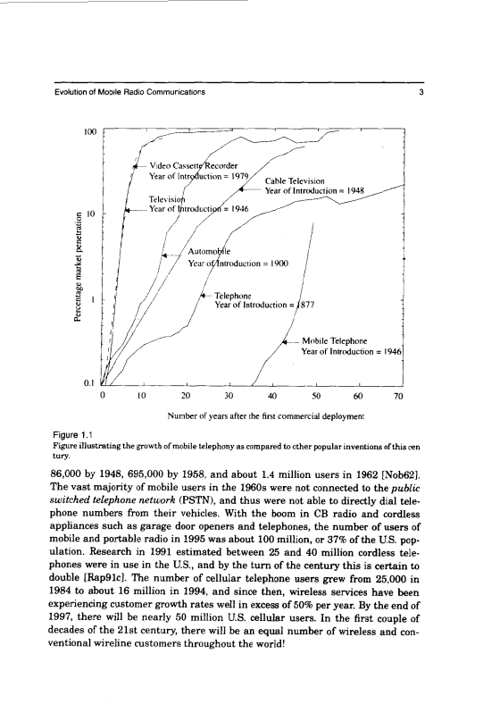www.vsofts.net oldroad

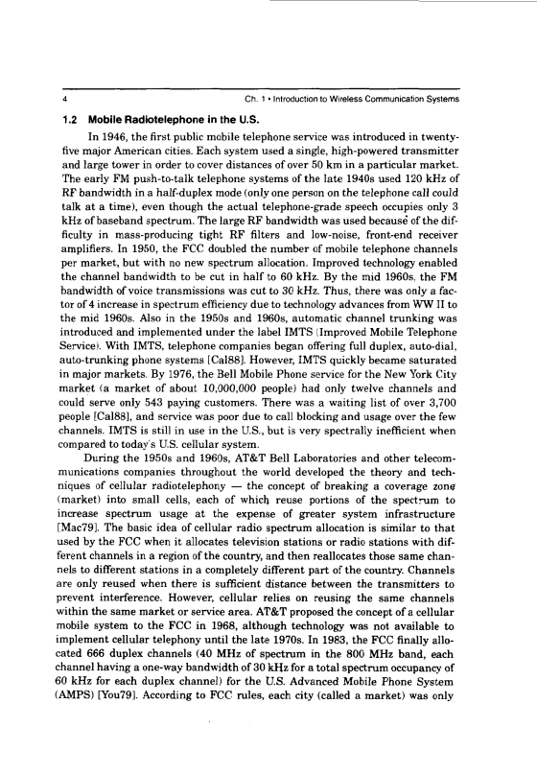www.vsofts.net oldroad

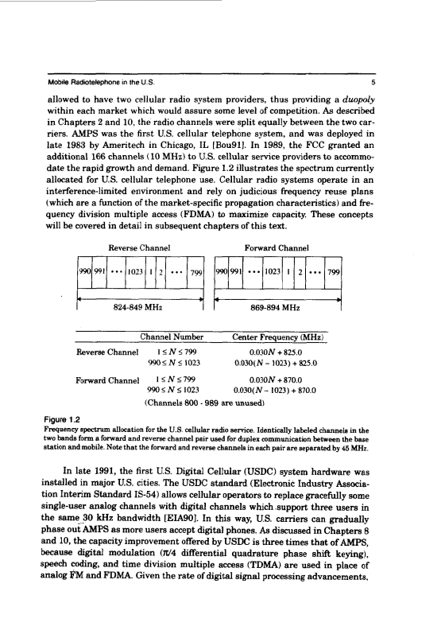www.vsofts.net oldroad

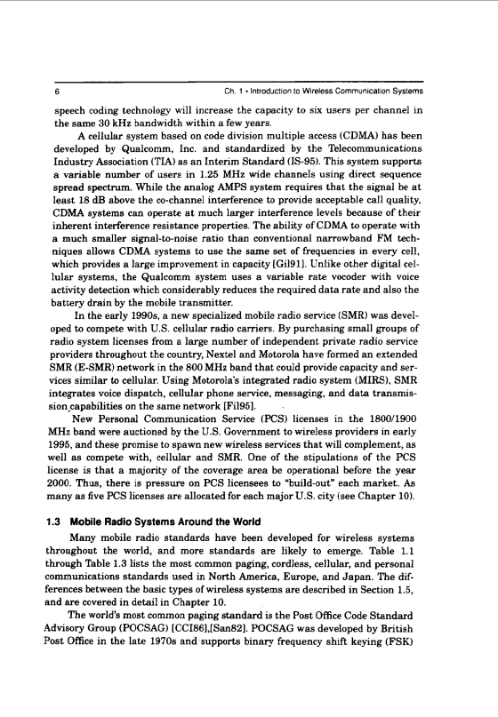www.vsofts.net oldroad

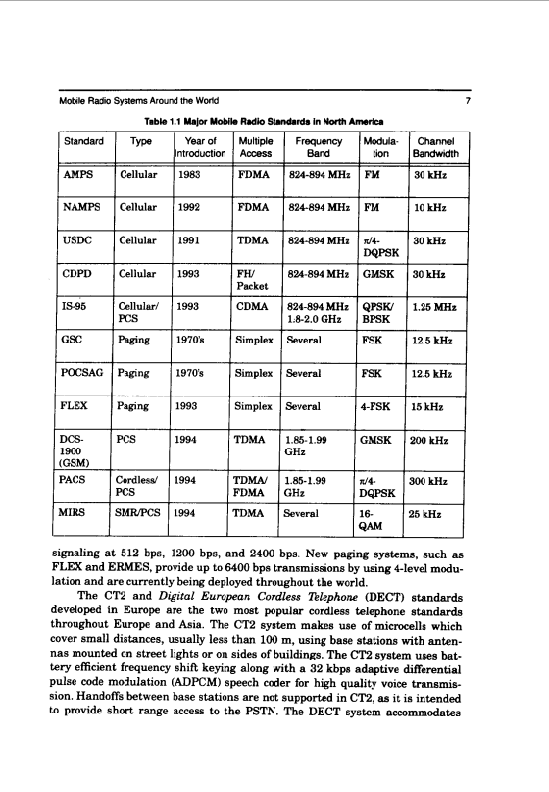www.vsofts.net oldroad

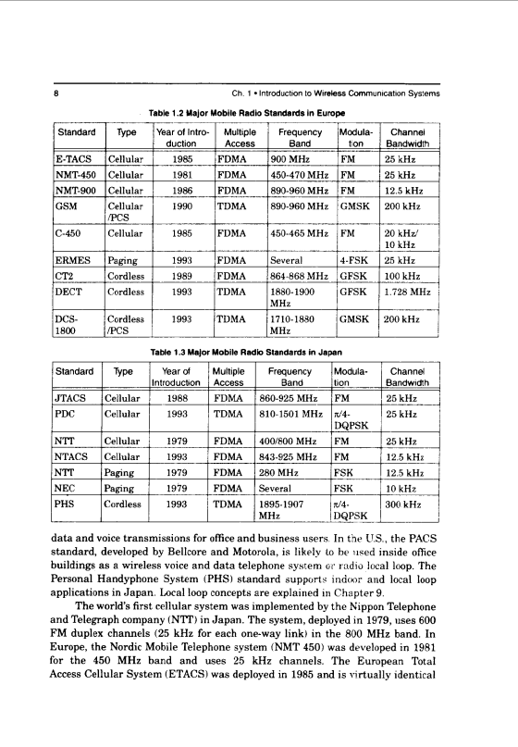www.vsofts.net oldroad

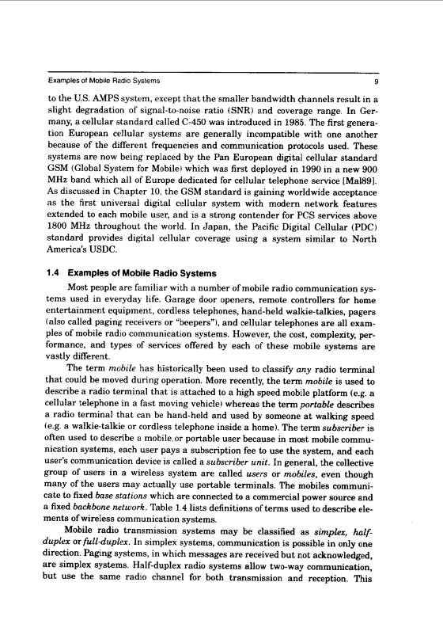www.vsofts.net oldroad

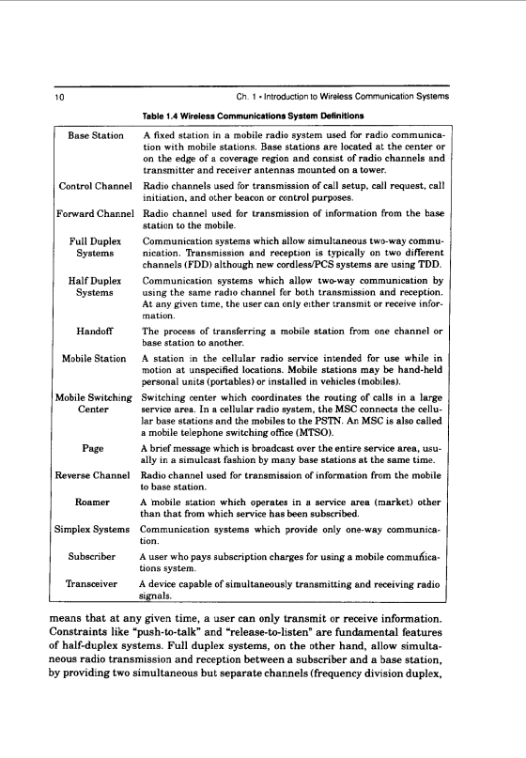www.vsofts.net oldroad

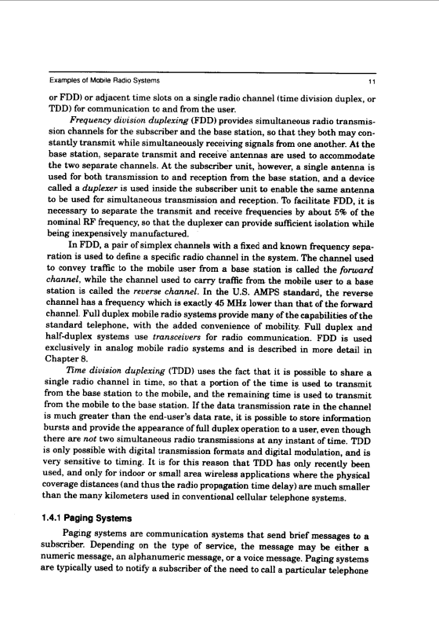www.vsofts.net oldroad

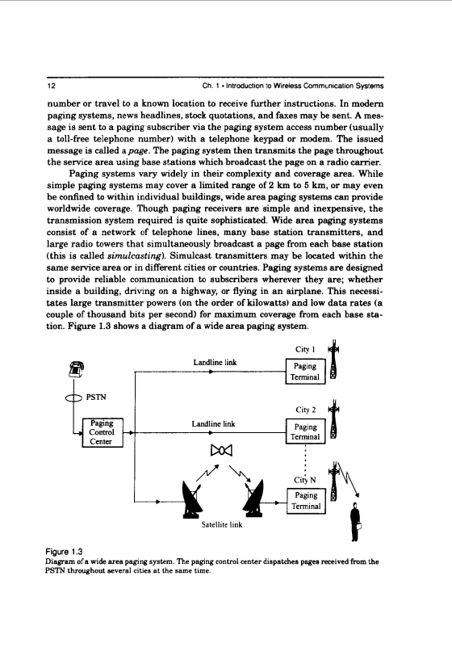www.vsofts.net oldroad

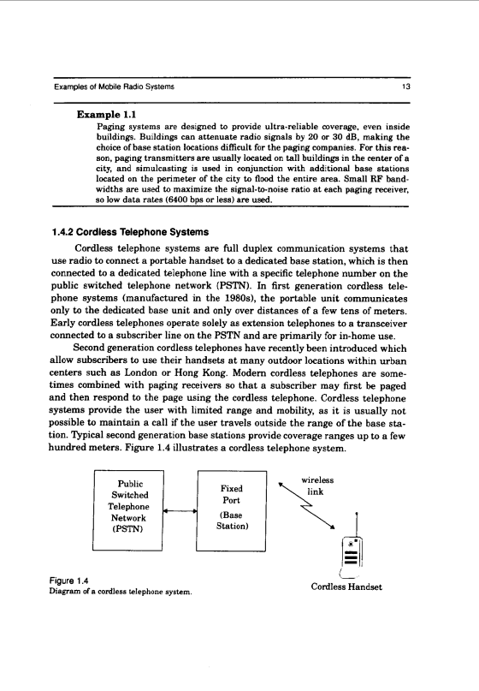www.vsofts.net oldroad

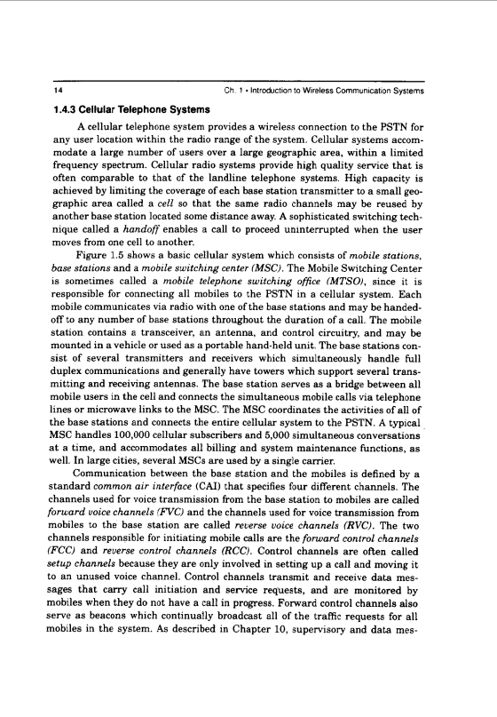www.vsofts.net oldroad

www.vsofts.net oldroad

www.vsofts.net oldroad

www.vsofts.net oldroad

www.vsofts.net oldroad

www.vsofts.net oldroad

www.vsofts.net oldroad

www.vsofts.net oldroad

www.vsofts.net oldroad

www.vsofts.net oldroad

www.vsofts.net oldroad

www.vsofts.net oldroad

www.vsofts.net oldroad

www.vsofts.net oldroad

www.vsofts.net oldroad

www.vsofts.net oldroad

www.vsofts.net oldroad

www.vsofts.net oldroad

www.vsofts.net oldroad

www.vsofts.net oldroad

www.vsofts.net oldroad

www.vsofts.net oldroad

www.vsofts.net oldroad

www.vsofts.net oldroad

www.vsofts.net oldroad

www.vsofts.net oldroad

www.vsofts.net oldroad

www.vsofts.net oldroad

www.vsofts.net oldroad

www.vsofts.net oldroad

www.vsofts.net oldroad

www.vsofts.net oldroad

www.vsofts.net oldroad

www.vsofts.net oldroad

www.vsofts.net oldroad

www.vsofts.net oldroad

www.vsofts.net oldroad

www.vsofts.net oldroad

www.vsofts.net oldroad

www.vsofts.net oldroad

www.vsofts.net oldroad

www.vsofts.net oldroad

www.vsofts.net oldroad

www.vsofts.net oldroad

www.vsofts.net oldroad

www.vsofts.net oldroad

www.vsofts.net oldroad

www.vsofts.net oldroad

www.vsofts.net oldroad

www.vsofts.net oldroad

www.vsofts.net oldroad

www.vsofts.net oldroad

www.vsofts.net oldroad

www.vsofts.net oldroad

www.vsofts.net oldroad

www.vsofts.net oldroad

www.vsofts.net oldroad

www.vsofts.net oldroad

www.vsofts.net oldroad

www.vsofts.net oldroad

www.vsofts.net oldroad

www.vsofts.net oldroad

www.vsofts.net oldroad

www.vsofts.net oldroad

www.vsofts.net oldroad

www.vsofts.net oldroad